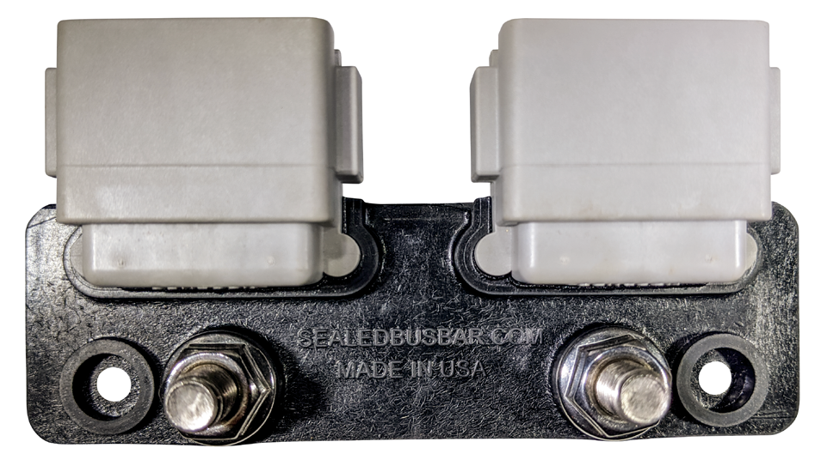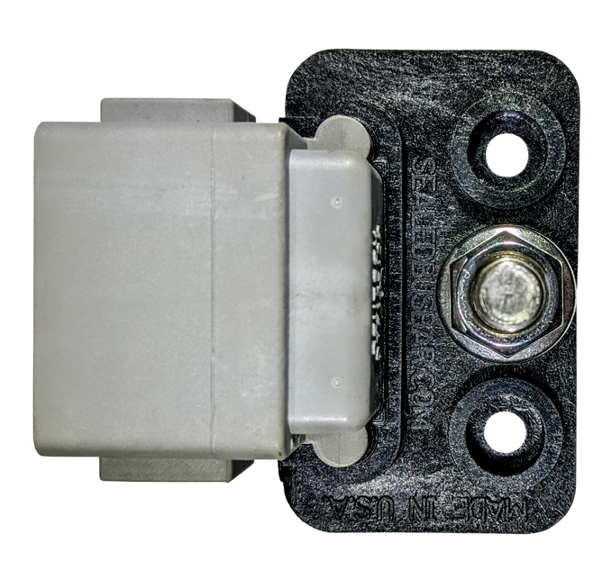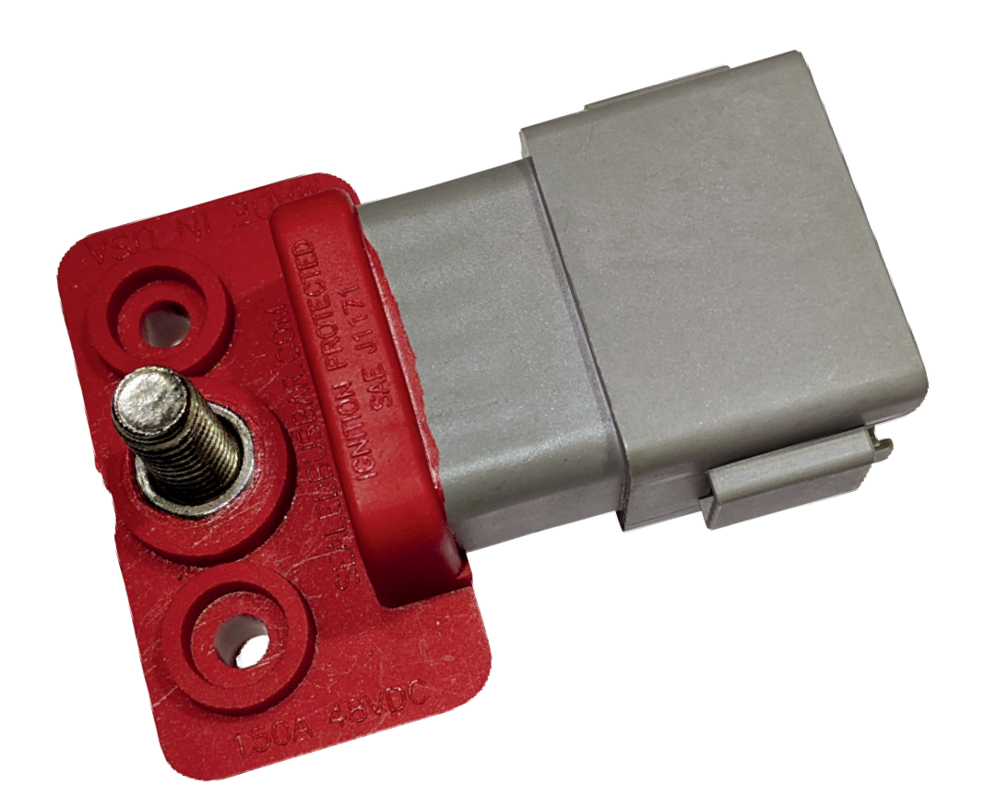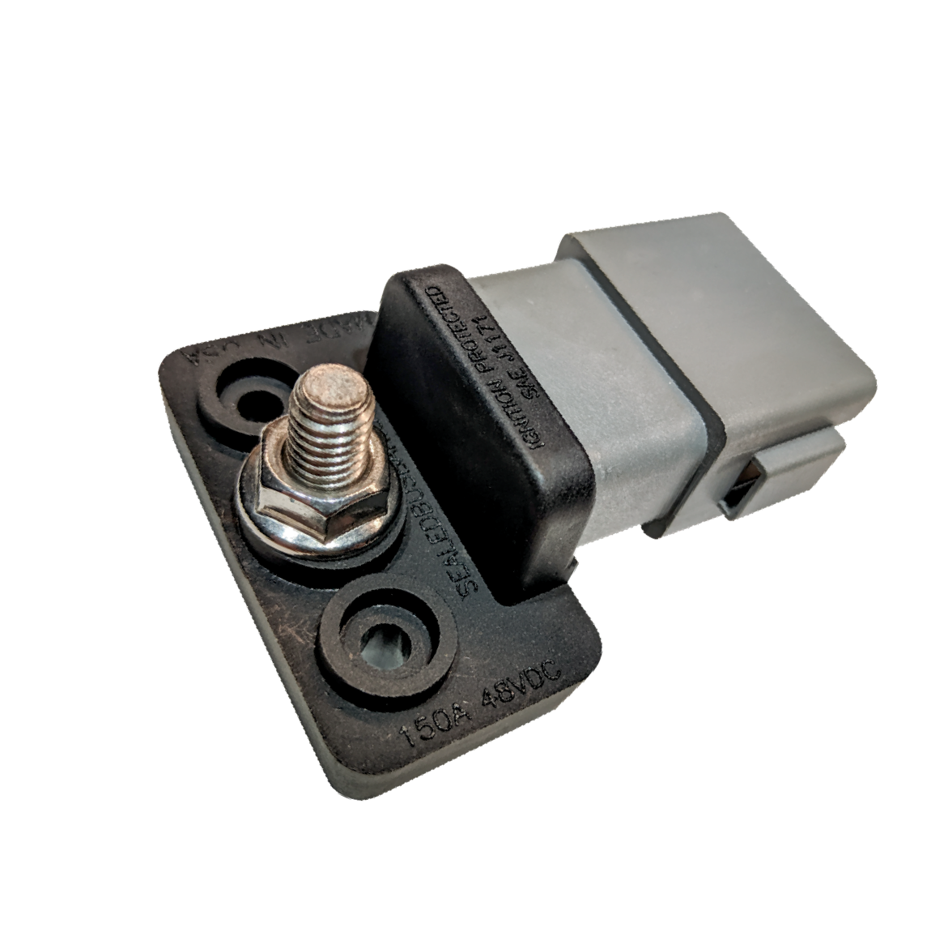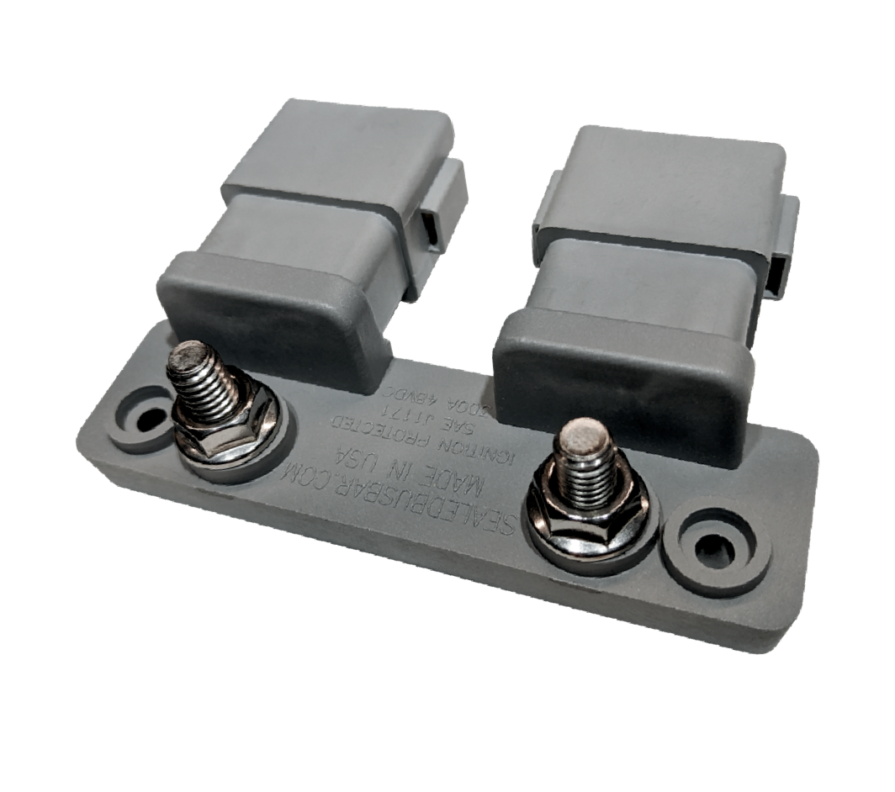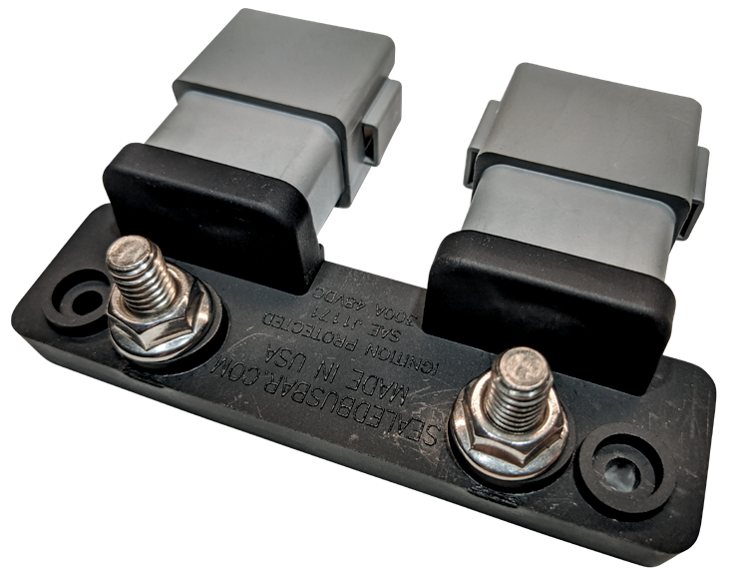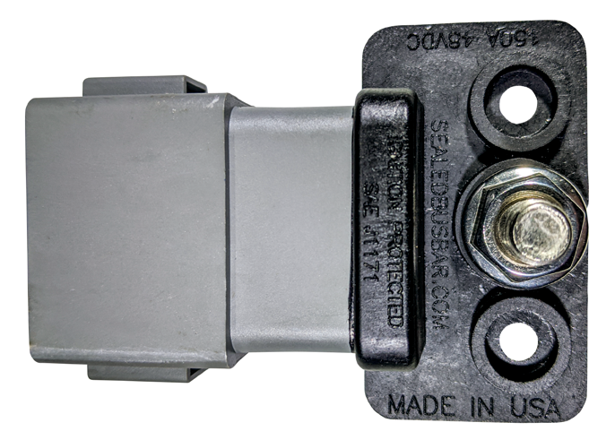

SBB-24 & SBB-24R
Rating | 300A @ 48V DC
Dimensions1 | 4-⅝" L x 2-⅜" W x 1-⅜" T
The Best Protection for Your Electrical System
SBC-24 & SBC-24R
Rating | 300A @ 48V DC
Dimensions1 | 4-⅝” L x 2-¾” W x 1-⅜” T

www.SealedBussBar.com

SBB-12 & SBB-12R
Rating | 150A @ 48V DC
Dimensions1 | 2" L x 2-⅜" W x 1-⅜" T

SBC-12 & SBC-12R
Rating | 150A @ 48V DC
Dimensions1 | 2” L x 2-¾” W x 1-⅜” T

SPLIT

1: Dimensions for width do not include mating
Common To All Sealed Buss Bar Models
Mating Connector2 | Deutsch: DT06-12SA Amphenol: AT06-12SA Molex: 93445-6212
Stud | 5/16-18 Stainless
Mounting Hole | #10 Pan Head
Buss Material | C1100 Electrolytic Copper
Base Material | RETPU – Injection Molded

connector.
2: See the product information for SBB2-12 & SBB-SHP which have different mating connectors.
SBC2-12 & SBC2-12R
Rating | 2x 150A @ 48V DC
Dimensions1 | 4-⅝” L x 2-¾” W x 1-⅜” T

Custom color and keyed connectors available by special order. Minimums may apply.

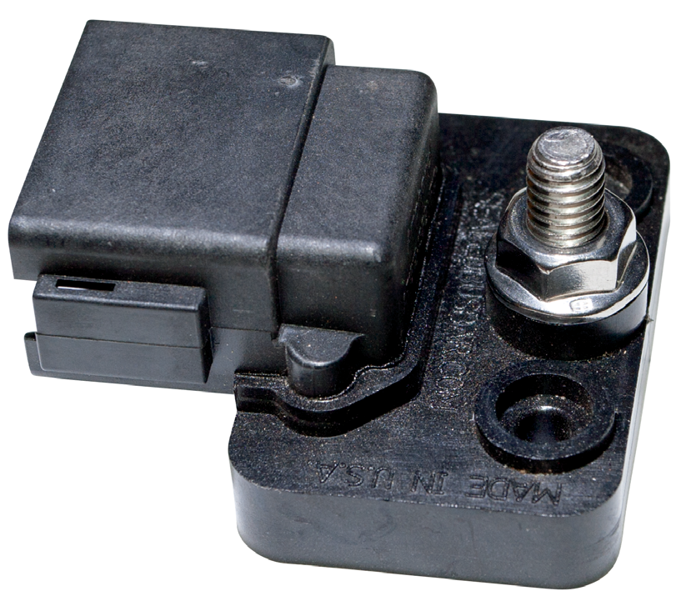
HIGH POWER SINGLE

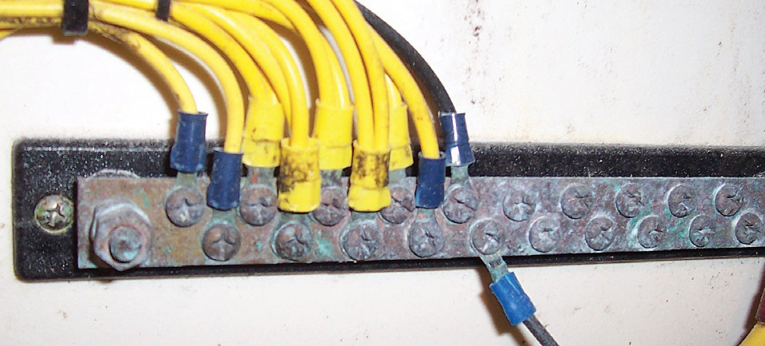

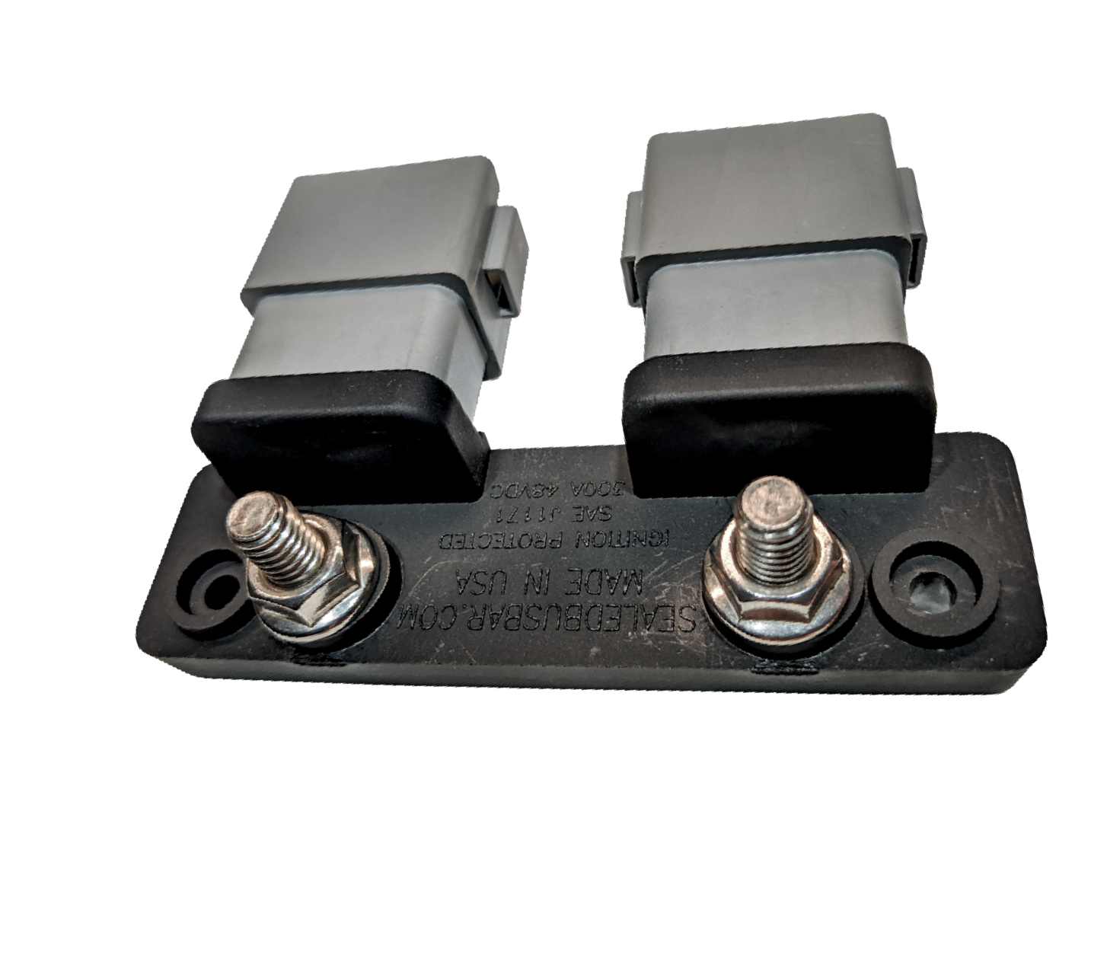
Traditional Buss Bars

Have you spent the resources to seal your electrical system’s pumps, lights and
- Exposed conducting plate may corrode
- Screws may loosen over time
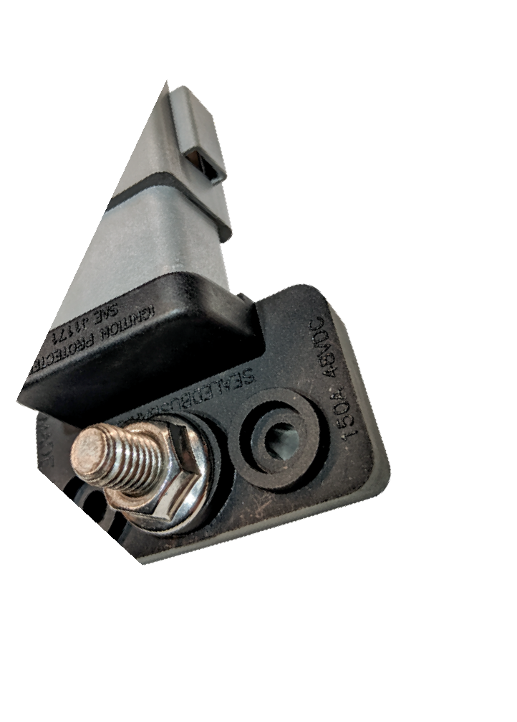
- Time consuming to install connections

SPLIT
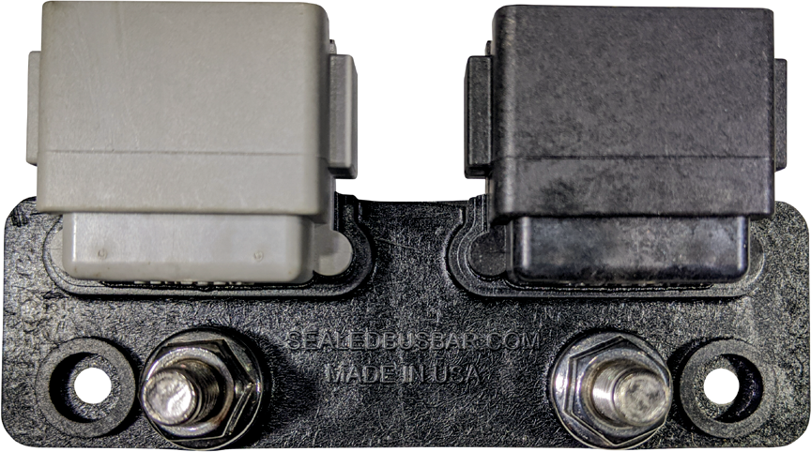

SBB2-12 & SBB2-12R
Rating | 2 x 150A @ 48V DC
 | Deutsch: DT06-12SA &
 | DT06-12SB
Mating | Amphenol: AT06-12SA &
Connector | AT06-12SB
 | Molex: 93445-6212 &
 | 93445-6221
Dimensions1 | 4-⅝” L x 2-⅜” W x 1-⅜” T

Our Sealed Buss Bar
SBB-SHP
Rating | 200A @ 48V DC
Mating Connector | Amphenol: AT1612SA-13SB
Wire Sizes | 2 @14-10ga  11 @18-14ga
Dimensions1 | 2” L x 2-⅝” W x 1-⅜” T

- Main Conducting Plate is encapsulated to protect from corrosion
- No Screws to loosen
- Plug and Play design installs in seconds

Save time and money with our design
- IP67 Sealed Connector (submersible)
- Ignition Protection to SAEJ1171 at 100% Continous Rating
- Compact Size
- Made in USA
- Maintenance free design
- Design meets or exceeds Coast Guard, ABYC, and NMMA standards.
other critical electrical only to leave the job unfinished?
With traditional buss bars you have done just that. They have many individual connections which can be prone to failure. They have exposed copper or brass plates that may have tin plating protection or none at all. The exposed plates will corrode which will require replacement.
Our innovative design encapsulates the conductive plate copper leaving the only exposed metal the stainless studs for the connections to the battery ensuring a stable electrical connection for the life of your electrical system.

